**DATACO SUPPLY CHAIN REPORT**

**I. Introduction**

The "Dataco Supply Chain" dataset consists of 52 columns. Within the constraints of time and analytical scope, I analyzed the dataset from four perspectives:

- Sales

- Quantity

- Customers

- Orders

Additionally, there are two findings on the "golden time" and the top product categories that contribute significantly to revenue.

*Note: On the left side of the dashboard pages, there are slicers for geography, time, and order status, allowing viewers to easily filter by specific objects.

**II. Visualization Process and Results**

**1. Sales Dashboard**

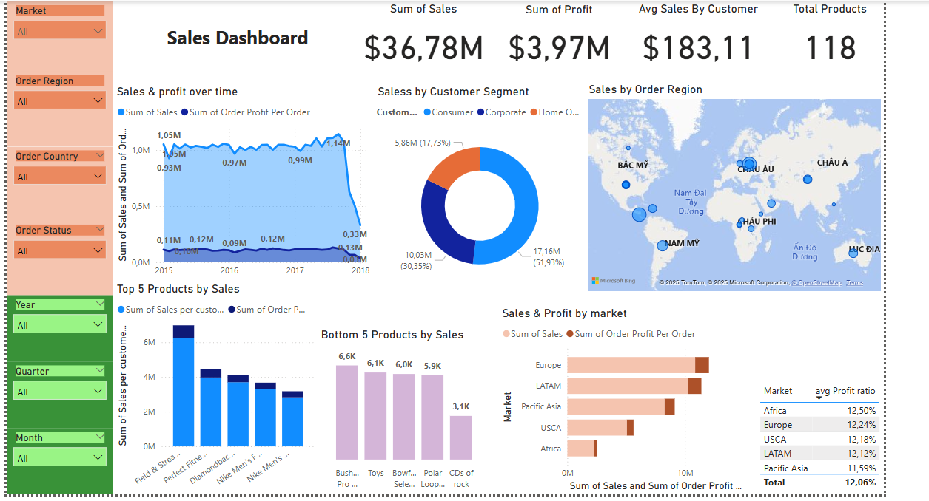

From 2015 to late 2017, revenue and profit remained stable, with a profit ratio of approximately 10% compared to revenue. However, at the beginning of 2018, revenue and profit experienced a sharp decline.

- Revenue generated by the Consumer customer group accounted for more than half (51.93%), while the Corporate group (30.35%) generated nearly twice the revenue of the Home office group (17.73%).

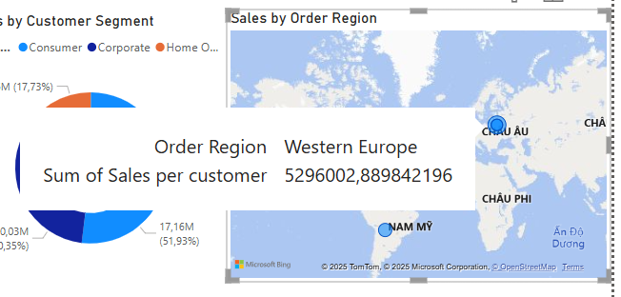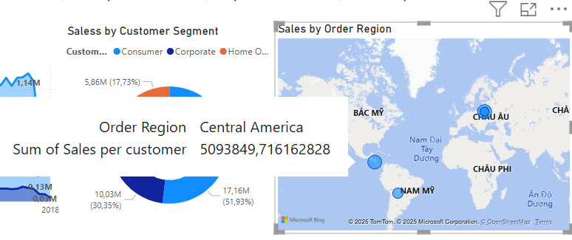

- Western Europe and Central America are the two regions generating the highest revenue compared to all other regions (accounting for 16.02% and 15.41%, respectively).

- The product generating the most revenue and profit is Field & Stream Sports Man 16 Gun Fire Safe, while the product generating the least revenue is CDs of Rock.

- Two markets with impressive sales (above 10M) are Europe and LATAM, but Africa leads in profit margins despite modest sales compared to other markets.

**2. Customer Dashboard**

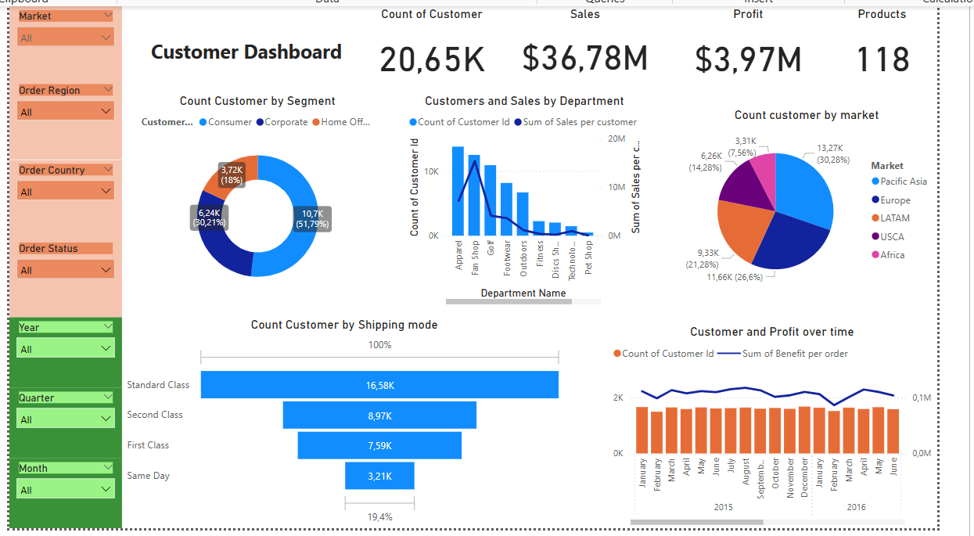

The Consumer customer group accounted for more than half (51.79%), while the Corporate group (30.21%) had nearly twice as many customers as the Home office group (18%). This correlates with the revenue distribution by customer segment shown in the "Sales Dashboard."

- Among the two departments with the largest number of customers, Apparel and Fanshop, there is an inverse correlation between the number of customers and the revenue they generate for that department. Specifically, in the Fanshop department, fewer customers created more revenue compared to the Apparel department.

- Among the two markets with the largest number of customers, besides Europe with impressive sales (as seen in the Sales Dashboard), the Pacific Asea market had more customers but did not contribute significantly to revenue.

- The number of customers choosing Standard Class and Second Class shipping modes was more than double those choosing First Class and Same Day. 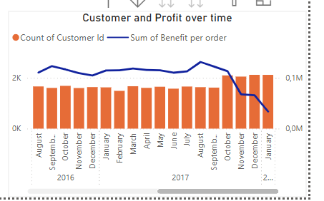

- Although customer numbers and profit remained stable over the months, from October 2017 to January 2018, customer numbers increased while profit decreased, highlighting issues with products, inventory, and the organization's delivery process.

**3. Quantity Dashboard**

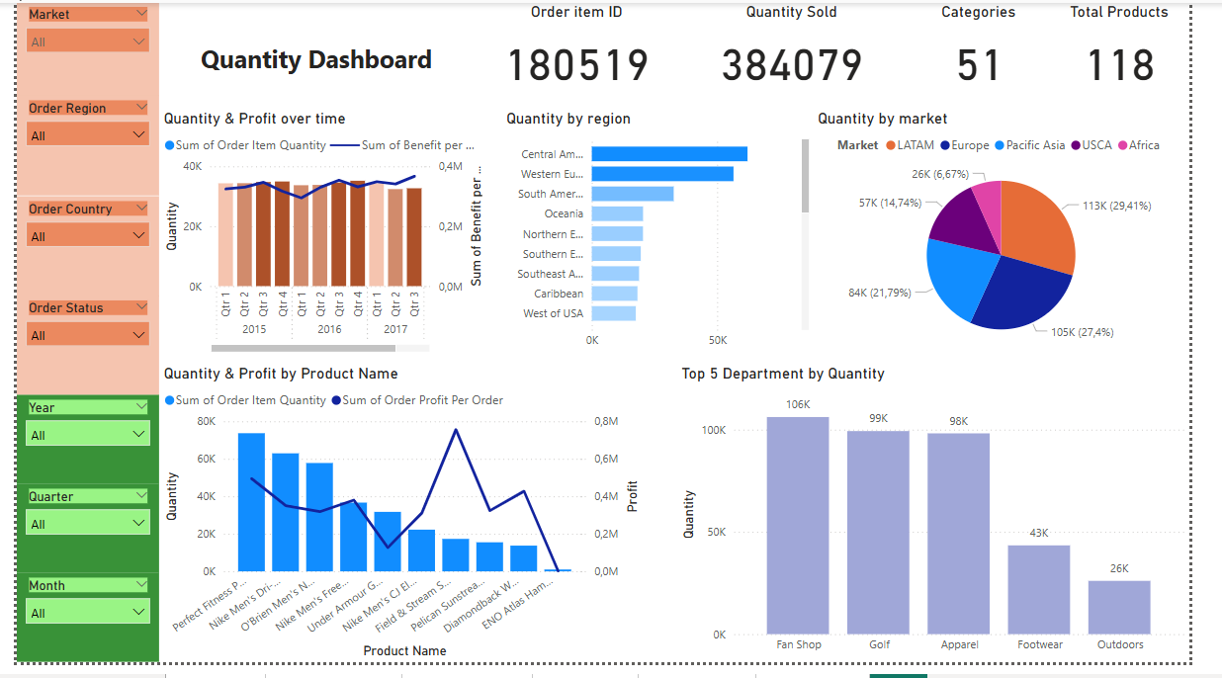

- In 2015 and 2016, quantity and profit typically peaked in the third and fourth quarters.

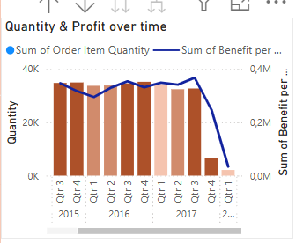… However, in the third and fourth quarters of 2017, lower quantities led to decreased profit.

- Two regions leading in quantity are Central America and Western Europe, which are closely linked to revenue results in these regions.

- This also applies to the two markets with the highest quantities: LATAM (including Central America) and Europe (including Western Europe).



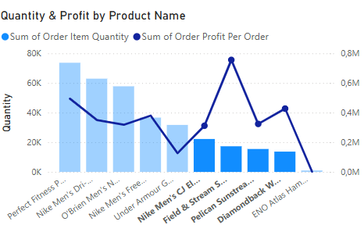

- Four products—**Nike Men's CJ Elite 2 TD Football Cleat, Field & Stream Sportsman 16 Gun Fire Safe, Pelican Sunstream 100 Kayak,** and **Diamondback Women's Serene Classic Comfort Bi**—had relatively low quantities but generated impressive profits (ranging from 0.3M to 0.8M).

- The three departments with excessively high quantities—Fanshop, Golf, and Apparel—each had double the quantity of the fourth department, Footwear.

**4. Order Dashboard**

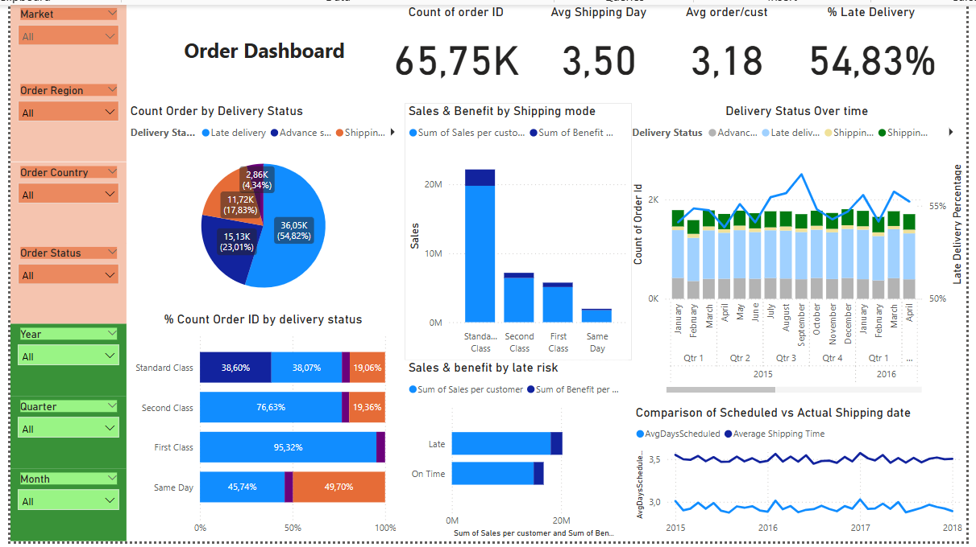

Firstly, late deliveries still accounted for a high proportion compared to other delivery statuses. Specifically, regarding shipping modes:

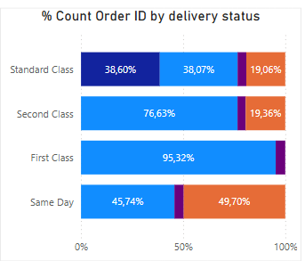

It can be seen that in the shipping mode of First Class and Second Class, the rate of late delivery is very high. It is necessary to improve and reduce the rate of late delivery in Same Day and especially Standard Class. The reasons are:

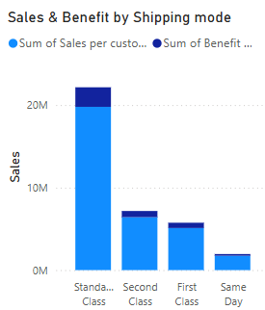

As the chart above shows, Standard Class still brings in much more revenue than other shipping modes. All modes need to improve their delivery speed, and Standard needs to improve the most if it doesn’t affect revenue.

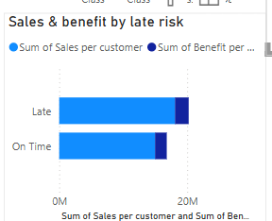

Another thing to note is that the revenue from late delivery is still higher than on-time delivery, which needs to be improved to increase positive customer experience and encourage customers to return.

**5. Khám phá thêm từ dữ liệu**

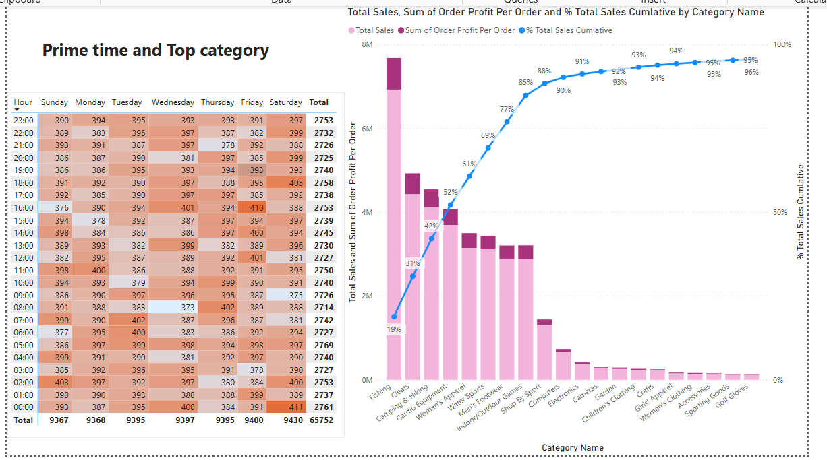

Regarding the golden hour, the initial idea was to create an information field about the current hour at the time of the transaction (order date). From there, create a matrix to count the order frequency in each time frame for each day of the week. In the above matrix, we see that the time frames 02:00 on Sunday, 07:00 on Tuesday, 16:00 on Friday and 00:00 on Saturday are the ideal time frames to publish a promotion program, advertise accompanying products (when this data set is taken from the e-commerce platform) to increase the effectiveness of reaching customers.

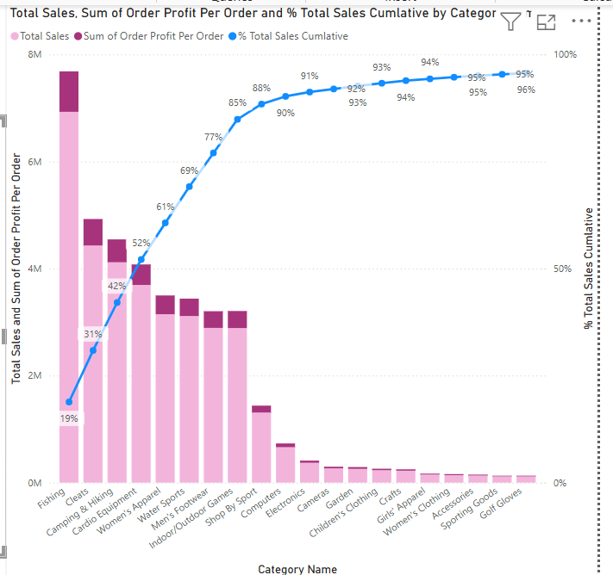

First, sort the categories in descending order of sales, then calculate the percentage of cumulative revenue through each category (already sorted) -> find the categories that bring in the most revenue for the company

Create the Running Total Sales measure: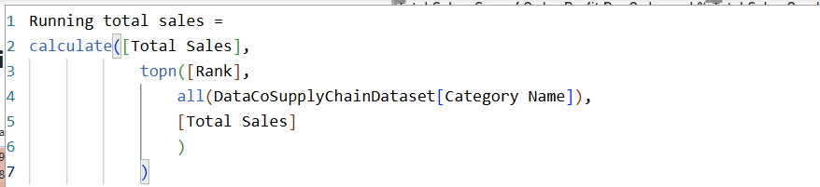

Total Sales:

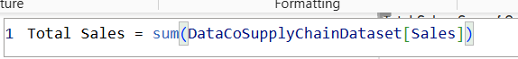

The Parato (% of cumulative revenue) would be the following calculation: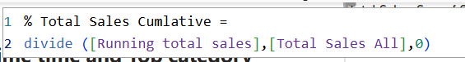

With a pareto level of 80%, we can identify the following product categories: Fishing, Cleats, Camping & Hiking, Cardio Equipment, Women’s Apparel, Water Sports, Men’s Footwear, which bring in 80% of the company’s revenue. Special attention and promotion of production and business in these categories is needed to optimize revenue and profit.